**Project report for the topic Data Engineering Semester 1 2024**

|  |  |
| --- | --- |
| Student name: | Thai Quang Le |
| FAN ID: | Le0424 |
| Email address: | Le0424@flinders.edu.au |
| Class enrolled | COMP8031 |
| Tutorial class: | COMP8031 |
| Group name: | Naruto |
| Names of other group members | 1) Thai Quang Le  2) Minh Quan Do Bui  3) Kimchheng Lim  4) Kazuya Tsubone |

1. **Data Wrangling**
   1. **Loading the data**

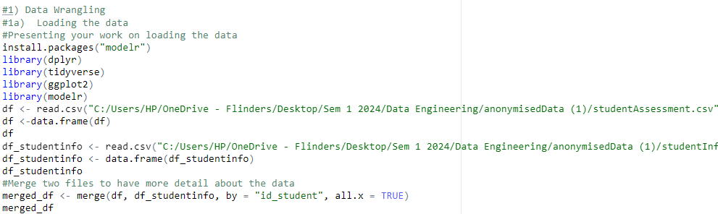

In this step, I used the read.csv function to load the Assessment.csv user data. A data frame named df is used to store data. I loaded libraries like dplyr, tidy, and ggplot2 and modelr for data manipulation and presentation. To get more information about the data, I decided to merged 2 dataset to make it more manageable.

* 1. **Handling missing data**



Next, I cleaned the dataset by removing the rows containing missing values using the na.omit function. This resulted in a cleaned dataset named merged_df with no missing values.

* 1. **Tidying the data.**

In this step, I tidied the data by converting the binary variable is_banked to a more readable format. We used the if-else function to replace the binary values (1 and 0) with "Yes" and "No," respectively. The same technique have been used for the two other variables.

1. **Data Transformation**
   1. **Data Transformation techniques**

To narrow the volume of the dataset, I will filter the range of the date_submitted >0

* 1. **Creating new variables**

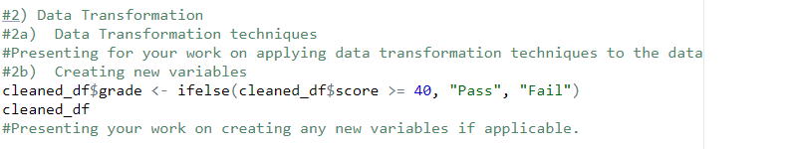 One of the critical data transformation techniques I applied was creating a new variable grade based on the score variable. I used the if else function to categorize the scores into "Pass" or "Fail" based on a threshold of 40.

1. **Data Analysis**
   1. **Statistical analysis or exploratory data analysis**

In this step, I conducted statistical analysis and exploratory data analysis (EDA) to uncover patterns, trends, and relationships within the dataset.

I first created a histogram of the score variable to visualize the distribution of scores. The histogram revealed a right-skewed distribution, indicating that the median score is greater than the mean score.

Next, I calculated the mean and median scores to understand the central tendency of the data further.

* 1. **Data visualisation**

I applied various data visualization techniques to further explore the dataset.

I created a scatter plot to visualize the relationship between the date submitted and the score, suggesting that more time spent submitting may affect students' scores.



I then created a histogram to show the distribution of scores, indicating that the highest number of students scored around 80.



Additionally, a boxplot was created to visualize the distribution of scores and identify outliers below a score of 25.

And then I created two types of facet graph: 1 variable and 2 variables



Lastly, a bar chart was generated to show the number of students in each grade category (Pass/Fail).

1. **Data Modelling**

In this step, I developed several linear models to analyse the relationship between variables in the dataset.

* 1. **Simple linear model**

I first developed a simple linear model to understand the relationship between date_submitted and score.

I created a simple linear model based on the data of score and date_submitted. In this case, the score is the dependent variable, and the date_submitted is the dependent variable.

* 1. **General linear model**
     1. **Predictors are categorical.**



Next, I developed a general linear model where the predictor are gender and disability categorical and the predicted variable is the score.

* + 1. **Predictors are categorical and continuous.**

We then created a general linear model where the predictors date_submitted and gender are both categorical and continuous.



* + 1. **Predictors are continuous.**

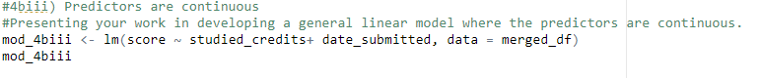

* 1. **Model evaluation**

RMSE of part 4a: 19.08101

RMSE of part 4bi: 19.08056

RMSEof part 4 bii: 19.08013

RMSE of part 4biii: 19.05115

* 1. **Model Interpretation**

In this part, the dependent variable is score and the independent variable is date submitted. According to the results of simple linear model show us that date_submitted has a negative impact to the score of students. These results mean that when the date submitted of students increase, they tend to get a lower score.

Coefficients for genderMale (-0.45) and disabilityY (-2.63): Compared to the reference group, being male (genderMale) is associated with a decrease in score of approximately 0.45, and having a disability (disabilityY) is associated with a decrease in score of approximately 2.63, holding other variables constant.

Both Male and have disability has a negative impact to the score but disability will affect stronger than the gender.

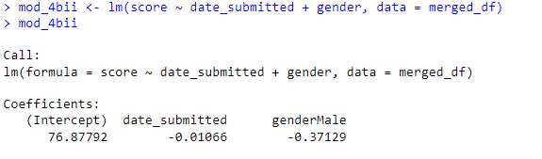

#In this model, both two independent variables have negative impact on the dependent variable. So, when the students increase the date submitted and gender_Male, the score will tend to get lower but gender will have more affect to the score.

Coefficients for studied_credits (-0.03) and date_submitted (-0.01): For each additional studied_credit, we expect the score to decrease by approximately 0.03, holding date_submitted constant. For each unit increase in date_submitted, we expect the score to decrease by approximately 0.01, holding studied_credits constant.